Mrs. Meixsell/Mrs.Brinton: 2018 Movie Poster

Independent Reading Assignment

Project Description: Imagine that your independent reading novel is being made into a movie (again, but don’t use the actual movie posters—make your own). Create a movie poster that advertises the upcoming movie. Here are some examples of posters of books made into movies.
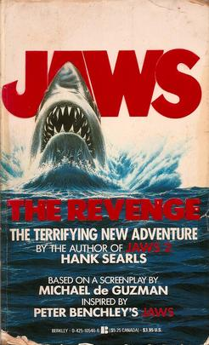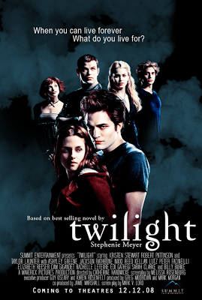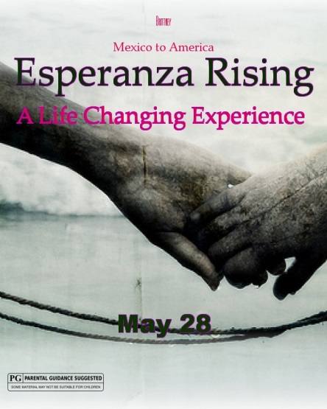

Project Requirements:

- Must be created on a large poster board (22” x 28”), NOT A TRIFOLD.
- Title must be in large writing and should stand out on your movie poster.
- Your name should appear on the poster as either the director or producer.
- A major illustration or collage should be the focus of your poster. It should give a good idea of the theme of the novel.
- The main characters of the novel will be the cast in your movie. Choose famous movie stars or television stars that you know of and “cast” them in the different character roles for your movie. The stars of your movie should be named on your poster, and they may or may not be a part of the major illustration or collage.
- The movie poster must have a slogan or catch phrase that represents the mood or theme of the novel (see the Jaws “The Terrifying New Adventure,” for an example).

…AND…

- A rating of the novel must be on the poster.
Examples:

Recommended for the movie fan seeking a suspenseful and exciting adventure!

OR Not recommended for the movie fan that hopes to be entertained and thrilled.
Notes:
- This movie poster should reflect several weeks of thought and work. Detail, creativity, and neatness will be heavily considered in the grading process.
- Remember to follow the scoring rubric when creating your poster so that you include all of the requirements.
- You may draw, paint, use Photoshop, or use any type of art you would like but it does need to be your own work. Do not ask a friend or family member to illustrate for you. If you borrow images for a collage or Photoshop, make sure they are arranged in a way that shows your creativity.

Due Date:

Your movie poster is due on ___________October 29_______________________.

Grading Rubric

CATEGORY | 5 | 3 | 1 | Score
Required  Elements | The poster includes all required elements. | Most of the required elements are included on the poster. | Some of the required elements are included on the poster.
Graphics - Relevance | All graphics are related to the story and make it easy to understand. | All graphics are related to the story and most make it easy to understand. | All graphics relate to the story and some make it easy to understand.
Content | Written work is informative and creatively written. | Written work is mostly informative and creatively written. | Written work is somewhat informative and creatively written.
Writing Applications | Written work is free of spelling and grammatical errors. | Written work contains a minimal number of spelling or grammatical errors. | Written work contains several spelling or grammatical errors.
Organization | The poster layout is exceptionally well balanced and uncluttered with no white space. | The poster layout is balanced and uncluttered with minimal white space. | The poster layout is not well balanced. It is excessively cluttered and/or contains too much white space.
Attractiveness | The poster is exceptionally attractive in terms of design and neatness. | The poster is attractive in terms of design and neatness. | The poster is reasonably attractive though it may be a bit messy.
Originality | The poster reflects a high degree of student creativity in creation and/or display. | The poster reflects student creativity in creation and/or display. | The poster reflects some student creativity in creation and/or display.

Name_____________________________ Period ___ / Project Grade_________________

